**FITNESS HUB**

**1.ABSTRACT**

In light of India's burgeoning fitness culture and economic growth, the demand for convenient access to gym services has surged. To meet this demand, the design of an efficient and user-friendly gym webpage is essential. This webpage aims to serve as a digital hub for gym enthusiasts, offering a range of features to enhance their experience. From streamlined membership registration and class scheduling to personalized workout plans and virtual training sessions, the webpage caters to the diverse needs of gym-goers. Moreover, it provides valuable information about gym facilities, trainers, and upcoming events, fostering community engagement and loyalty. Through its intuitive interface and comprehensive functionalities, the gym webpage serves as a one-stop platform for individuals looking to embark on their fitness journey or maintain an active lifestyle.

**2.INTRODUCTION**

Welcome to the digital era of fitness empowerment and community connection. In today's fast-paced world, prioritizing health and wellness is paramount, regardless of where you are on the globe. As societies worldwide embrace the importance of staying active, the demand for convenient access to fitness resources has soared.

Our gym webpage represents a beacon of accessibility and inclusivity in the realm of fitness. It serves as a virtual hub where individuals from all walks of life can embark on their fitness journey, regardless of their location or level of experience. With a user-friendly interface and an array of features, our webpage aims to demystify the path to a healthier lifestyle and make fitness more attainable for everyone.

Join us as we explore the myriad functionalities of our gym webpage, designed to cater to the diverse needs and preferences of individuals worldwide. From seamless membership registration and flexible class scheduling to personalized workout plans and virtual training sessions, our platform is equipped with tools to support and motivate you every step of the way. At its core, our gym webpage is not just about booking workouts; it's about fostering a sense of belonging and camaraderie within the global fitness community. Whether you're looking to break a sweat, connect with fellow enthusiasts, or simply explore new avenues for staying active, our webpage is here to empower you on your journey to a healthier, happier life.So whether you're tuning in from bustling city streets or tranquil countryside, our gym webpage welcomes you with open arms. Get ready to embrace the power of technology and community as you embark on your quest for wellness. Together, let's redefine what it means to live a fit and fulfilling life in the digital age.

**3.PROBLEM STATEMENT**

In today's digitally driven world, accessing fitness resources and staying motivated to maintain an active lifestyle can be challenging. Despite the growing popularity of fitness activities, individuals often face obstacles such as limited access to gym facilities, difficulty in finding suitable workout classes, and a lack of personalized guidance and support.

Furthermore, the COVID-19 pandemic has underscored the need for alternative fitness solutions, as traditional gym settings may pose health risks or be inaccessible due to lockdowns and social distancing measures. As a result, there is a pressing need for a comprehensive online platform that addresses these challenges and empowers individuals to pursue their fitness goals from the comfort and safety of their own homes.

Thus, the problem at hand is to develop a gym website that serves as a holistic solution for fitness enthusiasts, offering convenient access to a wide range of resources, personalized workout plans, virtual training sessions, and a supportive community environment. This website should cater to individuals of all fitness levels and backgrounds, providing them with the tools and motivation needed to lead healthier, more active lives, regardless of their location or circumstances.

**4. METHODOLOGY**

* PROJECT PLANNING AND REQUIREMENTS GATHERING:

a. Define the scope and objectives of the Fitness Hub Website.

b. Gather requirements from Customers, including administrators, and Coachers.

c. Identify key features and functionalities required, such as user authentication, customer registration, membership, notifications , and reporting.

* SYSTEM DESIGN:

a. Design the architecture of the Fitness Hub Website, including frontend and backend components.

b. Define the database schema to store user data, member information, coacher’s information and gym records.

c. Plan the technology stack, including the use of HTML, CSS, JavaScript, PHP, and MySQL.

* FRONTEND-DEVELOPMENT:

a. Develop the user interface using HTML for structure, CSS for styling, and JavaScript for interactivity.

b. Implement responsive design to ensure the application is accessible and usable on various devices and screen sizes.

c. Create pages for user authentication (login, registration), membership form, gallery interface, pricing, review’s , suggestion and contact.

* BACKEND-DEVELOPMENT:

a. Set up the server environment with PHP and MySQL support.

b. Develop server-side scripts using PHP to handle user authentication, data processing, and database interactions.

c. Create APIs for communication between the frontend and backend, using JSON or XML for data exchange.

* DATABASE IMPLEMENTATION:

a. Set up the MySQL database and configure tables to store user credentials, customer details, coachers details and gym records

b. Define relationships between tables and enforce data integrity constraints using primary keys, foreign keys, and unique constraints.

c. Populate the database with sample data for testing purposes.

* INTEGRATION AND TESTING:

a. Integrate the frontend and backend components to create a cohesive Fitness Hub Website.

b. Conduct unit testing to ensure individual components function correctly.

c. Perform integration testing to validate interactions between frontend and backend components.

d. Conduct user acceptance testing with stakeholders to verify that the system meets requirements and expectations.

* DEPLOYMENT:

a. Deploy the Fitness Hub Website to a web server or hosting platform.

b. Configure server settings and permissions to ensure security and performance.

* EVALUATION AND IMPROVEMENT:

a. Evaluate the effectiveness of the Fitness Hub Website based on factors such as user satisfaction, system reliability, and fitness integrity.

b. Gather feedback from stakeholders and implement improvements based on lessons learned and evolving requirements.

c. Continuously iterate and enhance the website to adapt to changing technological and regulatory updates.

* SOFTWARE AND HARDWARE REQUIREMENTS:

a. SOFTWARE INTERFACES:

1. HTML - has been used for developing the User Layout for the system

2. CSS - has been used for designing the web pages of the system

3. JAVASCRIPT – has been used to make website more responsive and dynamic.

4. Database – MySQL

5. PHP Script

b. HARDWARE INTERFACES:

1. Processor -Intel Pentium IV or more

2. Ram - 512 MB or more

3. Cache - 1 MB

4. Hard Disk - 10 GB recommended.

**6. DIAGRAMS**

1.USE CASE DIAGRAM:

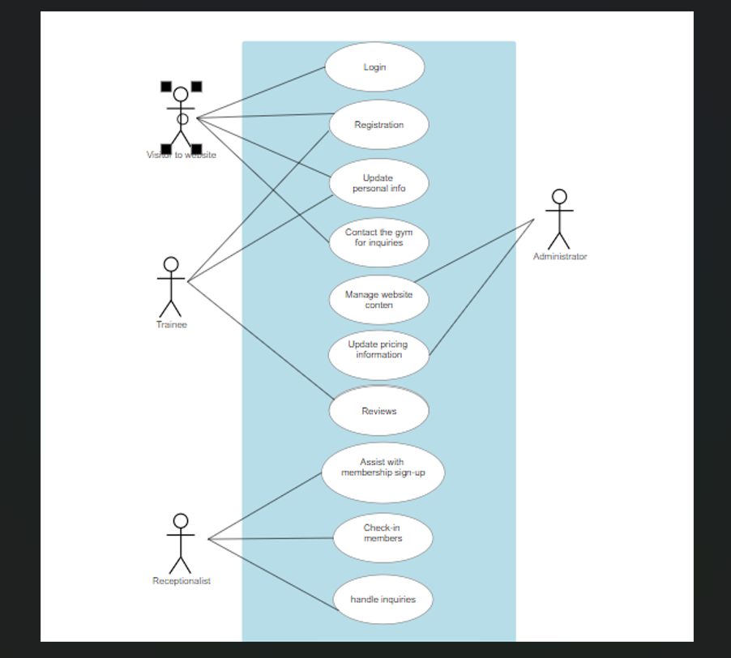

2. FLOW DIAGRAM:

2 a. Login flowchart :

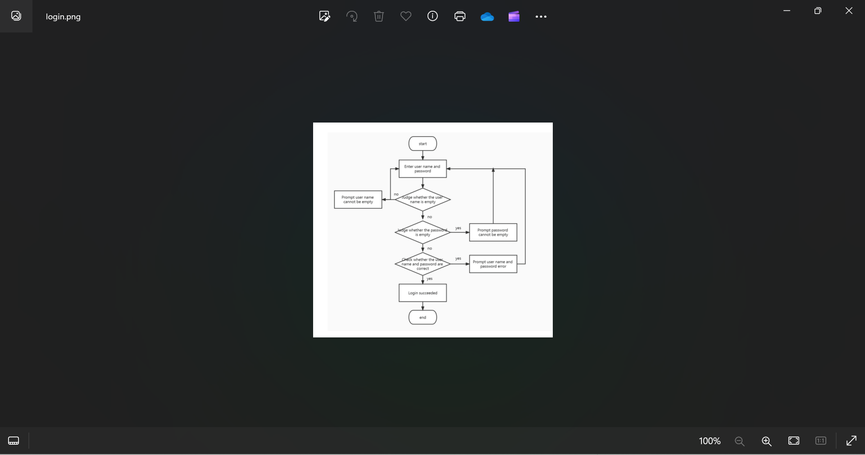

2 b. Registration flowchart :

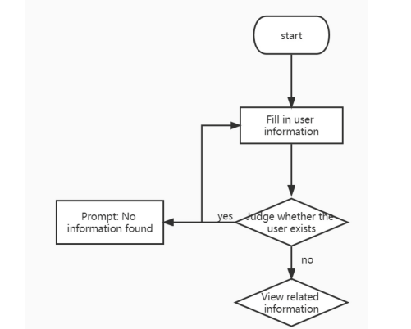

**7. CONCLUSION**

In Conclusion, this dynamic website contains nine pages- Home, Coaches, Gallery, Pricing, Reviews, Contact, Join, Login and Register. In the Home Page there is welcoming Message, boxes of services provided by the gym followed by the login and registration form and Contact information. In coaches page there are details of all the trainees provided by the gym. In contact page User can see the Phone no., Mail id and Address of the gym and in Register Page user can register himself by simply filling in the information.

The information of user registration will be stored in MySql Database. The information is saved using PHP and Mysql connection.

Visual Studio Code has been deployed to write the HTML, CSS and PHP code whereas Xampp has been used for MYSQL database. The Image folder contains all the images and logos that have been used in the website. Whole Website is written using HTML, styled using CSS with internal CSS and the connection to MYSQL Database will be setup using PHP code.

It is a simple website that can be used by local gym owners for advertisements and user registration.

**8. REFERENCES**

* <https://www.youtube.com/watch?v=GjqvmRqQyO8>
* <https://www.youtube.com/watch?v=gpqoZQ8GNK8>
* <https://webflow.com/made-in-webflow/gym>
* <https://colorlib.com/wp/gym-websites-design/>
* <https://gymdesk.com/blog/management-software-definition/>
* <https://www.matellio.com/blog/smart-gym-management-software-development/>
* <https://www.softwaresuggest.com/gym-management-software>
* [https://www.studocu.com/in/z/26994894?sid=017133504](https://www.studocu.com/in/z/26994894?sid=01713350445)